**DEPARTMENT OF INFORMATION TECHNOLOGY & DATA SCIENCE**

**VIDYALANKAR SCHOOL OF INFORMATION TECHNOLOGY**

**OJT Report**

Submitted in partial fulfilment of the  
requirements for the award of the Degree of

**MASTER OF SCIENCE (INFORMATION TECHNOLOGY)**

**Semester – II**

**By**

**MANE SIDDHESH**

**Seat No: 1312118**

**DEPARTMENT OF INFORMATION TECHNOLOGY**

**VIDYALANKAR SCHOOL OF INFORMATION TECHNOLOGY**

**(Affiliated to University of Mumbai)**

**MUMBAI, 400 037, MAHARASHTRA**

**Academic Year 2023 – 2024**

**CERTIFICATE**

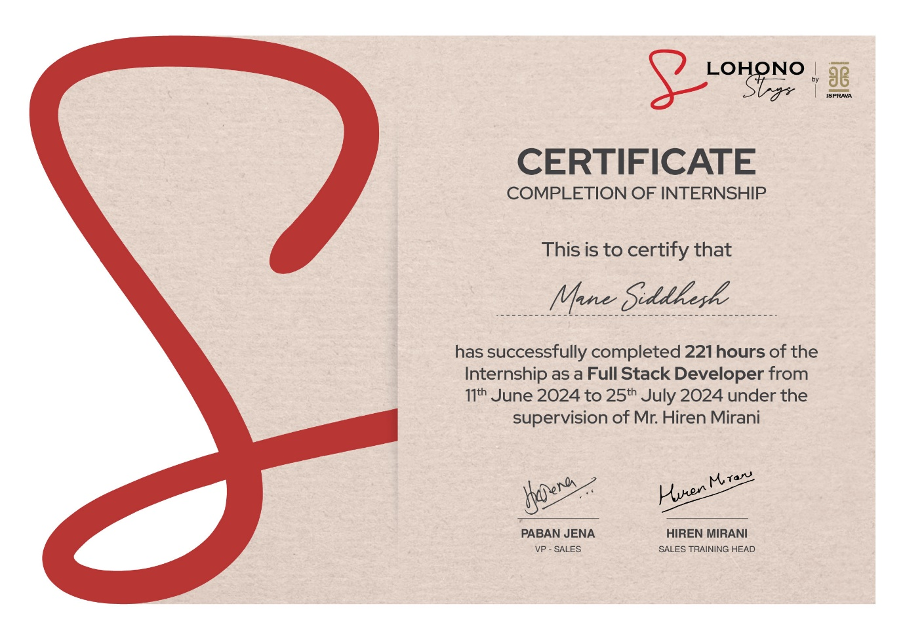

**INDEX**

|  |  |  |
| --- | --- | --- |
| **Sr. No** | **Content** | **Pg. No** |
|  | **OJT Report** |  |
| **1** | Introduction | 4 |
| **2** | Company Overview | 5 |
| **3** | Training Objective | 6 |
| **4** | Training Experience | 6 |
| **5** | Skills Developed | 7 |
| **6** | Achievements & Contributions | 8 |
| **7** | Challenges Faced | 8 |
| **8** | Lessons Learned | 9 |
| **9** | Conclusion | 9 |
| **10** | References | 9 |
|  | **Appendices** |  |
| **I** | Resume | 10 |
| **II** | Joining Letter | 12 |
| **III** | Student Diary Log | 13 |
| **IV** | Attendance Sheet | 15 |

**ON-THE-JOB TRAINING EXPERIENCE REPORT**

**Name of the Student:** MANE SIDDHESH SANJAY

**Name of the organization:** Lohono Stays By Isprava

**Department/Division Where Training took place:** Parel, Mumbai

**Duration of Training [Start Date to End Date of Training]:** 11-06-2024 to 09-08-2024

**Date of Submission: [Date of Submitting the Report]:**

The following is a suggested outline. However, the students are advised to consult their respective OJT Mentors.

**INTRODUCTION**

**Objective:**

To gain hands-on experience in web development and quality assurance at Lohono Stays by Isprava. Learn and apply industry-standard practices in creating and maintaining websites and web applications. Understand team methodologies, protocols, and project workflows. Enhance critical thinking and technical skills in coding, debugging, and testing. Observe and participate in the full development lifecycle, from planning to deployment. Develop proficiency in using various web development tools and frameworks. Improve problem-solving abilities by tackling real-world challenges. Contribute to the development of innovative and user-friendly web solutions.

**Career Impact:**

Enhance technical proficiency and collaborative skills in a professional web development environment. Increase employability in both tech industry roles and related fields. Gain valuable experience with diverse development tools and frameworks, providing a competitive advantage. Build a strong foundation in both front-end and back-end development. Understand the importance of quality assurance and testing in delivering robust applications. Develop a portfolio of projects showcasing practical skills and contributions. Gain insights into industry trends and best practices through mentorship and observation. A certificate from this internship adds substantial value to my professional credentials and marketability.

**Goals:**

1. Develop and maintain user-friendly web applications.

2. Acquire new web development and QA skills.

3. Apply these skills to improve practical proficiency and contribute to organizational goals.

**Roles and Responsibilities:**

* Front-end Development
* Back-end Development
* Database Management
* Quality Assurance and Testing

**COMPANY OVERVIEW**

**Lohono Stays by Isprava**

Lohono Stays by Isprava is a premier luxury villa rental company that offers exclusive vacation homes in some of the most beautiful locations in India and beyond. Founded with a vision to provide unparalleled luxury and comfort, Lohono Stays curates unique holiday experiences that combine world-class amenities with the charm of local culture and landscapes.

Isprava, the parent company, is renowned for its bespoke holiday homes that epitomize opulence and elegance. Lohono Stays extends this legacy by offering a collection of meticulously maintained properties, each with its own distinct character and style. From beachfront villas in Goa to serene mountain retreats in Alibaug and beyond, Lohono Stays ensures that every stay is a memorable one.

**Key features of Lohono Stays include:**

Curated Luxury: Each villa is handpicked for its unique design, stunning location, and luxurious amenities.

Personalized Service: Guests enjoy tailor-made services, including private chefs, concierge assistance, and housekeeping, ensuring a seamless and indulgent stay.

Exquisite Properties: The portfolio includes a diverse range of properties, from contemporary homes to traditional villas, all designed to provide the utmost comfort and privacy.

Attention to Detail: Every aspect of the guest experience is meticulously planned, from the interior decor to the personalized welcome hampers.

Lohono Stays is dedicated to creating unforgettable holiday experiences by combining luxury, comfort, and impeccable service. Whether it's a family vacation, a romantic getaway, or a corporate retreat, Lohono Stays offers the perfect setting for any occasion.

**TRAINING OBJECTIVE**

As an intern working on a handbook portal for a villa rental company, my primary focus was on developing and refining the portal to enhance user experience and efficiency. I worked on creating and structuring content that would be easily accessible and informative for users. This included integrating features such as detailed property descriptions, booking information, and amenities lists to ensure clarity and usefulness.

I learned to use HTML and CSS to design and style the portal, ensuring it was visually appealing and user-friendly. JavaScript was used to add interactive elements, such as dynamic search filters and responsive design features, to improve the portal's functionality.

Additionally, I utilized MS Excel for data management and cleaning tasks, ensuring that the information displayed in the portal was accurate and up to date. This involved organizing data about properties, amenities, and booking details to streamline the content and enhance the user experience.

Throughout the project, I focused on optimizing performance, ensuring that the portal loaded quickly and efficiently. I conducted thorough quality audits, including code reviews and testing, to identify and resolve any issues, ensuring the portal met high standards of reliability and user satisfaction. This experience improved my skills in web development, data management, and quality assurance, preparing me for future challenges in the field.

**TRAINING EXPERIENCE**

During my training at Lohono Stays, I focused on improving the villa rental handbook portal. I used HTML, CSS, and JavaScript to create a responsive and visually appealing design. My tasks included adding interactive features, such as dynamic search filters, to enhance user experience.

I also managed and cleaned data using MS Excel, ensuring that property information and booking details were accurate and up to date. This involved organizing data for smooth integration into the portal.

Quality assurance was a key part of my role. I conducted code reviews, performed various types of testing, and documented my findings to ensure the portal's reliability and functionality. This training not only strengthened my technical skills but also improved my problem-solving and data management abilities, setting me up for future success in web development.

**SKILLS DEVELOPED**

**Technical Skills**

HTML & CSS: Crafted visually appealing and user-friendly web pages with responsive designs and cross-browser compatibility. Utilized advanced techniques like Grid and Flexbox for flexible layouts.

JavaScript: Integrated interactive elements, such as dynamic search filters and user-triggered events, enhancing user engagement and functionality. Employed JavaScript libraries and AJAX for improved development and asynchronous data retrieval.

Node.js: Gained foundational knowledge in server-side programming, building and managing server-side applications and APIs. Used Express.js for routing and server management and implemented basic authentication and session handling.

SQL: Developed skills in writing and optimizing SQL queries for database management. Used SQL for data retrieval, manipulation, and integration, ensuring accurate and efficient handling of relational databases.

MS Excel: Applied for extensive data cleaning, validation, and organization. Performed complex data analysis and visualization tasks, utilizing formulas, pivot tables, and macros to ensure accurate and up-to-date information.

Quality Assurance: Executed rigorous code reviews, conducted performance and usability testing, and documented findings to ensure the reliability and effectiveness of the portal.

**Soft Skills**

Problem-Solving: Enhanced analytical skills by troubleshooting complex issues, devising solutions, and implementing fixes efficiently.

Attention to Detail: Focused on accuracy in both coding and data management, improving overall project quality and user satisfaction.

Collaboration: Engaged in effective teamwork, incorporating feedback, and working with colleagues to achieve project goals.

Time Management: Balanced multiple tasks and deadlines efficiently, demonstrating organization and productivity in a fast-paced environment.

Technical Documentation: Developed clear and thorough documentation for code, processes, and project updates, facilitating better understanding and future maintenance.

Adaptability: Adapted to new tools and technologies, showing flexibility and a willingness to learn in a dynamic work setting.

**ACHIEVEMENTS & CONTRIBUTIONS**

During my internship, I achieved several significant milestones and made impactful contributions. I successfully redesigned and developed a responsive villa rental handbook portal using HTML, CSS, and JavaScript, which greatly enhanced the user interface and overall user experience. By implementing dynamic search filters and interactive elements, I significantly improved user engagement and functionality. My expertise in SQL and MS Excel played a crucial role in managing extensive data sets, ensuring that the information integrated into the portal was both accurate and up to date.

In addition, I made valuable contributions to server-side development with Node.js and Express.js, helping to build robust and scalable back-end solutions. My dedication to quality assurance involved thorough code reviews and performance testing, which allowed me to identify and resolve critical issues, thereby boosting the portal's reliability and efficiency. I also developed clear and comprehensive technical documentation, facilitating easier maintenance and future enhancements. Throughout the project, I effectively managed my time and adapted to new tools and technologies, demonstrating strong organizational skills. My enhanced communication abilities enabled me to collaborate effectively with the team, present complex information clearly, and contribute to the successful delivery of high-quality outcomes.

**CHALLENGES FACED**

I faced several challenges during my internship that pushed me to grow and adapt. One significant challenge was redesigning and developing the responsive villa rental handbook portal. Ensuring that the portal was visually appealing and user-friendly across various devices required meticulous attention to detail and extensive testing.

Managing extensive data sets using SQL and MS Excel presented another challenge. Maintaining data accuracy and consistency while integrating this information seamlessly into the portal demanded advanced data management skills.

Working with Node.js and Express.js for server-side development introduced new complexities. Building robust and scalable back-end solutions required a deep understanding of these technologies. Debugging server-side issues, managing asynchronous code, and ensuring efficient routing and middleware integration were particularly challenging.

Quality assurance was another area where I encountered difficulties. Conducting thorough code reviews and performance testing to identify and resolve critical issues was time-consuming and required precision.

Balancing multiple tasks and deadlines tested my time management abilities. I had to prioritize effectively and stay organized to meet project milestones while adapting to new tools and technologies.

Improving my communication skills was also challenging. Clearly presenting complex information and collaborating effectively with the team required continuous practice and adjustment. These challenges collectively enhanced my technical proficiency, problem-solving capabilities, and overall professional development.

**LESSONS LEARNED**

During my internship, I discovered the critical importance of creating a seamless user experience. Designing interfaces that were both visually appealing and functional taught me how to enhance user engagement and satisfaction, emphasizing the need for intuitive design.

My work with SQL and data management was particularly enlightening. I gained expertise in cleaning, validating, and organizing extensive data sets, ensuring that the information integrated into the portal was both accurate and reliable, which is essential for effective data handling.

Developing back-end systems with Node.js and Express.js introduced me to the complexities of server-side programming. I learned how to tackle issues related to scalability and efficiency, gaining practical skills in building robust and scalable back-end solutions.

Quality assurance became a key focus, where I learned the importance of thorough code reviews and performance testing. This experience highlighted how precision in these areas directly impacts the reliability and efficiency of the system.

Balancing multiple tasks and deadlines taught me effective time management strategies. I improved my ability to prioritize and stay organized, which was crucial for meeting project milestones in a dynamic environment.

Adapting to new tools and technologies was another significant lesson. I learned to quickly acquire and apply new skills, which enhanced my ability to contribute effectively to project outcomes.

My communication skills also improved. I learned to present complex ideas clearly and work collaboratively with team members, which facilitated better teamwork and project coordination.

Lastly, solving problems under pressure sharpened my troubleshooting abilities. I became adept at addressing issues swiftly and efficiently, even when faced with tight deadlines. Working closely with the team underscored the value of feedback and collective effort in achieving project goals.

**CONCLUSION**

In conclusion, my internship was a highly enriching experience that significantly advanced my professional development. I mastered skills in user experience design, creating interfaces that were both visually appealing and user-friendly. Handling extensive data sets with SQL and Excel sharpened my data management abilities. Working with Node.js and Express.js deepened my understanding of server-side programming, while quality assurance practices taught me the importance of precision and thorough testing. Improved time management and adaptability helped me balance multiple tasks effectively. Enhanced communication skills facilitated better collaboration with team members. Overall, this internship provided me with a solid foundation of technical expertise and problem-solving skills, preparing me well for future challenges and career opportunities.

**REFERENCES**

[**https://www.lohono.com/**](https://www.lohono.com/)

[**https://www.isprava.com/**](https://www.isprava.com/)

**APPENDIX I: RESUME**

**Name**: SIDDHESH MANE

**Contact Number**: +91 9082249947

**Email ID**: [siddheshmane04@gmail.com](mailto:siddheshmane04@gmail.com)

**Education**

**HEI Name**: Vidyalankar School of Information Technology **Year**: 2025

**Degree / Specialization**: Master of Science in Information Technology

**CGPA**: 8.18 (Semester 1)

**HEI Name**: Vidyalankar School of Information Technology **Year**: 2023

**Degree / Specialization**: Bachelor of Science in Information Technology

**CGPA**: 9.28

**Internship / Work Experience**

**Information Technology Intern:** Lohono Stays by Isprava **Year**: 2024

**Brief**: Information Portal (Handbook), The company’s handbook portal offers the sales department easy access to essential information, including villa amenities and local attractions. Designed for simplicity and responsiveness, it ensures seamless experience with up-to-date details and user feedback options

**Teaching Assistant**: Vidyalankar School of Information Technology **Year**: 2024

**Brief**: Partnered with teacher to plan and implement lessons following Mumbai University curriculum, goals, and objectives. Facilitated learning for a classroom of 150+ students by preparing instructional materials in collaboration with the lead teacher.

**Academic Experience**

**Semester**: 5 (BSc.IT) **Year**: 2022

**Project**: NSS Blood Directory June 2022 - January 2023

**Brief**: “NSS Blood Directory” Web Application has two main Modules “Blood Camp Management” and “Blood Donor Management” The blood camp application will include upcoming camps details which will show the new camps details including activity time, venue, no. of volunteers needed, organizing NGO/Hospital, etc. The blood camp management module will also provide end to end functionality for organizing and managing blood camps and events.

**Other Achievements and Personal Interests**

* Incharge for Inter-College Techfest Named "TECHVISTA"
* Coordinator for Tantravihar and Tantradyan Intercollegiate Project Exhibition
* Participated in the Aavishkar and Tantravihar Inter-Collegiate Research Convention 2022–23
* Best "VSIT NSS Volunteer" for the Year 2021–22
* Member of the Computer Society of India (CSI) and an active volunteer at National Service Scheme (NSS)
* Board Infinity: Full Stack Development Certification & Alison: Advanced Excel 2021
* AAVISHKAR and TANTRAVIHAR Inter Collegiate Research Convention and Competition 2022-23
* Microsoft Introduction to Programming using JavaScript & MongoDB Basics by MongoDB University
* IIT Bombay: Introduction to Computers/CPP/HTML/C Language, Python 3.4.3/RDBMS/Blender/Arduino Training/R
* Maharashtra State Certificate in Information Technology- 93% & AICPTR's Computer Typing 30WPM (8000kdph)

**Languages Known**

English – Full Professional Proficiency

Hindi – Full Professional Proficiency

Marathi – Native/Bilingual Proficiency

**Computer Proficiency**

* HTML5 SQL
* CSS3 MongoDB
* JavaScript Power BI
* React JS Advanced MS-Excel
* Python Microsoft Office

**APPENDIX II: JOINING LETTER**

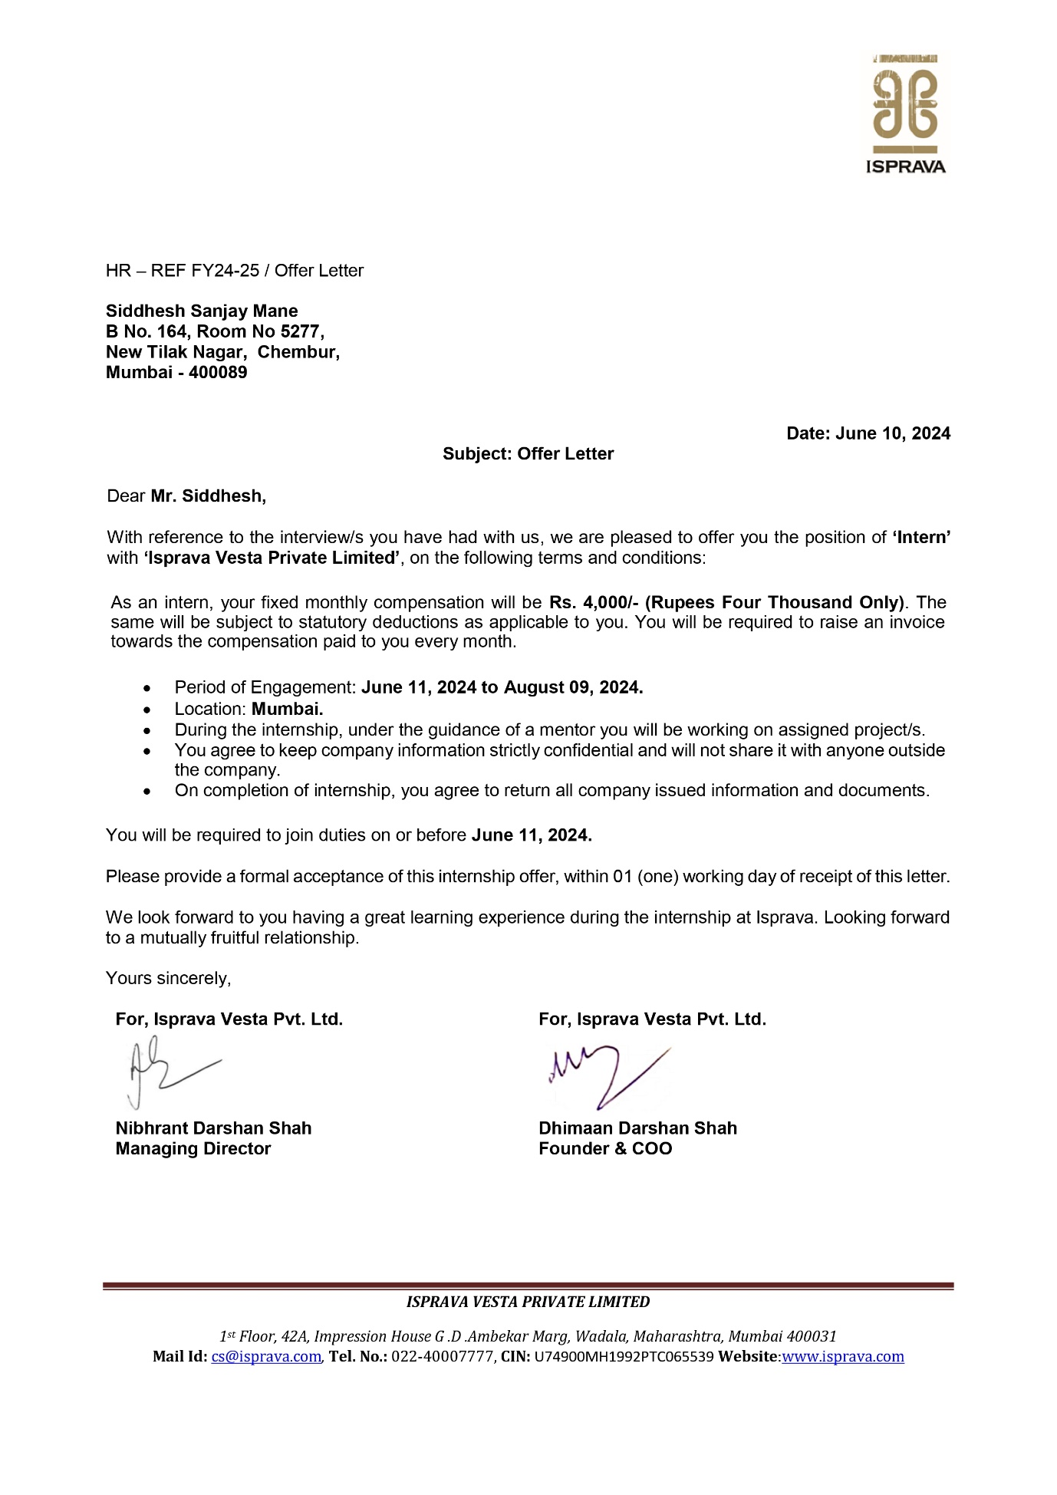

**APPENDIX III: STUDENT DIARY (LOG) RECORDING FORMAT**

|  |  |  |  |  |
| --- | --- | --- | --- | --- |
| **Week** | **Task Assigned** | **Activities Performed** | **Key Learnings** | **Additional Remarks** |
| **Week 1**  (11th - 14th June 2024) | User Requirement Analysis,  Creating Knowledge Base  &  Quality Assurance. | Understanding the requirements.  Creation of landing pages.  Assessing communication skills, product knowledge, objection handling, compliance with the processes, and adherence to legal and ethical standards. | What are         Functional & Non-Functional requirements.  Understanding the fundamental structure of an HTML page.  Establish criteria and benchmarks against which the audit will evaluate performance. | Handbook Portal |
| **Week 2**  (17th - 21st June 2024) | Admin Dashboard  &  Quality Assurance. | Login/Logout Functions & performing  CRUD operations access.  Assessing communication skills, product knowledge, objection handling, compliance with the processes, and adherence to legal and ethical standards. | User authentication and session control & handling data manipulation.  Establish criteria and benchmarks against which the audit will evaluate performance. | Handbook Portal |
| **Week 3**  (24th - 28th June 2024) | Database Management  &  Quality Assurance. | Creation of databases and schemas,  Connecting with APIs.  Evaluate each call against predefined criteria and score performance objectively. | Structure of data storage.  Integrating external services with APIs.  Take detailed notes and record observations regarding strengths, areas for improvement, compliance issues, and any deviations from established guidelines. | Handbook Portal |
| **Week 4**  (1st - 5th July 2024) | Working with APIs  &  Quality Assurance. | Connecting Frontend with the Backend through Node.js | Utilizing Node.js for server-side JavaScript execution and Express.js as a minimalist web framework to handle HTTP requests and responses.  Take detailed notes and record observations regarding strengths, areas for improvement, compliance issues, and any deviations from established guidelines. | Handbook Portal |
| **Week 5**  (16th - 19th July 2024) | Database Management | Creation of databases and schemas.  Connecting with APIs | Structure of data storage.  Integrating external services with APIs. | Handbook Portal |
| **Week 6**  (22nd - 26th July 2024) | Search Keyword | Optimizing search engines and databases to find relevant information. | Optimizing SEO elements, analysing keyword performance, and developing targeted content. | Handbook Portal |



**Signature of Industry/organization Supervisor**

**APPENDIX IV: ATTENDANCE SHEET**

**Name & Address of Organization**

**Lohono Stays by Isprava**

**3rd Floor, Citi Tower,**

**Parel (E), Mumbai - 400012.**

|  |  |
| --- | --- |
| **Name of the Student** | MANE SIDDHESH SANJAY |
| **Roll Number** | 23306A1034 |
| **Name of Course** | MSc.IT |
| **Date of Commencement of Training** | 11/06/2024 |
| **Date of Completion of Training** | 09/08/2024 |

Month & Year:

|  |  |  |  |  |  |  |
| --- | --- | --- | --- | --- | --- | --- |
| **Week** | **Monday** | **Tuesday** | **Wednesday** | **Thursday** | **Friday** | **Saturday** |
| **1** | - | P | P | P | P | - |
| **2** | P | P | P | P | P | - |
| **3** | A | P | P | P | P | - |
| **4** | P | P | P | P | P | - |
| **5** | A | A | A | A | A | - |
| **6** | A | P | P | P | P | - |
| **7** | P | P | P | P |  | - |

* The attendance sheet should remain affixed to the Daily Training Diary. Do not remove or tear it off.
* Holidays should be marked in Red Ink in the attendance column. Absent should be marked as ‘A’ in Red Ink.

**Mr. Hiren Mirani** (OJT Supervisor)

**Date** - 24/07/2024